**Ставим ось:**

1. **Ставим драйвера, паки**
2. **Ставим АД**
3. **DNS и WINS, NNTP, SMTP и .NET**
4. **Не ставим POP3**
5. **Ставим RPC**

**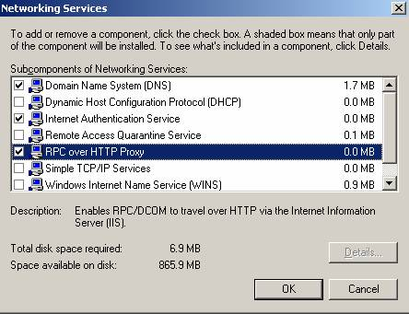**

1. **Патчим**
2. **Ставим Terminal**
3. **IIS + ASP.NET**
4. **Ставим SSL и сертификат**<http://www.startcom.org/> (1 год бесплатно, полная аутентификация)
5. **патчим**

Имя сервера – mail, рабочая группа – firma  
входим в АД с параметрами – mail и домен firma.com  
таким образом полное ДНС имя сначала mail.firma.local а потом получается mail.firma.com

**Ставим Эксчейндж:**

1. **Ставим всё что просит, Патчим**
2. **Открываем порты – 80, 443, 25, 993**
3. **Редактируем реестр**

|  |
| --- |
| Windows Registry Editor Version 5.00  [HKEY\_LOCAL\_MACHINE\SOFTWARE\Microsoft\Rpc\RpcProxy]  "Enabled"=dword:00000001  "ValidPorts"="mail:6001-6002;mail:6004;mail.liider.eu:6001-6002;mail.liider.eu:6004"  "AllowAnonymous"=dword:00000001  [HKEY\_LOCAL\_MACHINE\SYSTEM\CurrentControlSet\Services\MSExchangeSA\Parameters]  "HTTPFEPollingInterval"=dword:00000001  "HTTP Port"=dword:00001772  "Rpc/HTTP NSPI Port"=dword:00001774  [HKEY\_LOCAL\_MACHINE\SYSTEM\CurrentControlSet\Services\MSExchangeIS\ParametersSystem]  "Rpc/HTTP Port"=dword:00001771  [HKEY\_LOCAL\_MACHINE\SYSTEM\CurrentControlSet\Services\NTDS\Parameters]  "NSPI interface protocol sequences"=hex(7):6e,00,63,00,61,00,63,00,6e,00,5f,00,\  68,00,74,00,74,00,70,00,3a,00,36,00,30,00,30,00,34,00,00,00,00,00 |

1. **Настраиваем IIS: убираем «анонюмоус» и добавляем «секуре»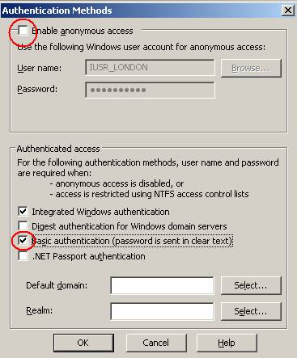**

**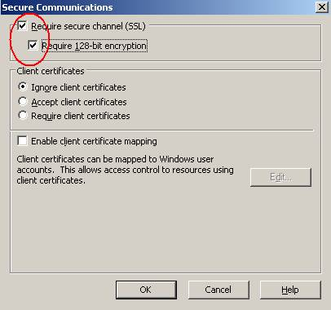**

1. **Настраиваем Exchange Admin**

To configure the back-end server to act as a target for the RPC proxy server

|  |
| --- |
| 1. Click Start, point to All Programs, point to Microsoft Exchange, and then click System Manager.  2. In Exchange System Manager, expand Administrative Groups, and then expand the administrative group that contains your Exchange back-end server.  3. Expand the Servers object, right-click the Exchange back-end server that you want to configure, and then select Properties.  4. On the Exchange Server Properties page, click the RPC-HTTP tab, and then select the option next to RPC-HTTP back-end server.  5. If you do not have a front-end server in your topology, you could receive a warning message as shown in the following figure. Click OK and proceed to the next step to configure the Exchange back-end servers.  Warning message—no front-end server configured  dialog_rpc  6. Click OK on the Exchange Server Properties page.  7. If your back-end server is also a global catalog server, you could receive an additional warning as shown in the following figure. Restart the back-end and global catalog server if this warning message appears.  Warning message—incorrect ports configured  BE_incorrect_ports   1. Perform this procedure on all Exchange Server 2003 SP1 back-end servers that RPC proxy servers need to be able to access.   1. In Exchange System Manager, expand Administrative Groups, and then expand the administrative group that contains your RPC proxy server.  2. Expand the Servers object, right-click the Exchange server that you have configured as the RPC proxy server, and then select Properties.  3. On the Exchange Server Properties page, click the RPC-HTTP tab, and then select the option next to RPC-HTTP front-end server.  The RPC-HTTP tab in Exchange System Manager  RPC_UI_Front_End  4. Click OK.  5. A warning message will appear stating that Secure Sockets Layer (SSL) is required for RPC over HTTP to work. Click OK. You must configure SSL on your Exchange front-end server for RPC over HTTP to work. Alternatively, you can select to offload SSL on another server. For information about how to do this, see [How to Configure the RPC Proxy Server to Allow for SSL Offloading on a Separate Server](#DSDOC_db50789e_c280_441f_8f53_932e5d6620). |

1. **Открываем безопасный IMAP4:**

<http://www.isaserver.org/img/upl/exchangekit/2003secureimap4/2003secureimap4.htm>

1. **Открываем OMA**<http://www.petri.co.il/configure_oma.htm>
2. **Проверяем HTTPS настройки – старт-рун: outlook /rpcdiag**

<http://www.petri.co.il/configure_exchange_2000_2003_to_receive_email_for_other_domains.htm>

1. **Проверяем mail.liider.eu #5.2.1 smtp;550 5.2.1 Mailbox unavailable. No reverse name (PTR) for your sender IP (212.7.7.206  
   MX запись должна форвардиться на hostname а не на IP адрес**
2. **Ставим автофорвард с mail.liider.eu на** [**http://mail.liider.eu/exchange/**](http://mail.liider.eu/exchange/)
3. **Настраиваем ORF (после установки он НЕ работает)**

[**http://system-administrators.info/?p=1680**](http://system-administrators.info/?p=1680)

[**http://kerio-rus.ru/index.php?option=com\_content&task=view&id=94&Itemid=79**](http://kerio-rus.ru/index.php?option=com_content&task=view&id=94&Itemid=79)